EU-ASE Response to Targeted Consultation for the Evaluation of the Guidelines on State aid for Environmental protection and Energy 2014-2020 (EEAG)
------------------------------------------------------------------------------------------------
18 July 2019

INTRODUCTION
EU-ASE was established in December 2010 by some of Europe’s leading multinational companies. The Alliance creates a platform from which our companies (Danfoss, Kingspan, Knauf Insulation, Saint-Gobain, Schneider Electric, Siemens, Signify, and Veolia) can join with politicians and thought leaders to ensure the voice of energy efficiency is heard from across the business and political community. EU-ASE members have operations across the 28 Member States of the European Union, employ over 340.000 people in Europe and have an aggregated annual turnover of €115 billion.

We would like to respond to the Roadmap that was released by DG Competition, namely on: 1) Targeted Consultation for the Evaluation of the Guidelines on State aid for Environmental protection and Energy 2014-2020 (EEAG)

*Please describe the relevance of State aid rules for you.
We believe that well-designed State aid schemes and measures can help achieve important policies in the Member States and in the EU such as reaching the 2030 targets while ensuring that the energy markets are affordable, flexible and secure. This is specifically to:
- Promote the financial investment in energy efficiency and use of renewable energy;
- Prevent the granting of aid that promotes carbon lock-in through investments in unsustainable projects and energy intensive infrastructure.

QUESTION 4
Based on your experience, to what extent has Article 39 GBER allowed aid through financial instruments for energy efficiency measures in buildings while limiting distortions of competition at the level of the financial intermediary and the funds involved?

To a large extent
To some extent
Not at all
I don’t know

Please explain (1000 character(s) maximum

As the GBER exempts Member States (MS) from notifying State aid measures it is crucial that it provides the highest level of legal certainty to the Commission(EC), the MS, market operators and public. While it is very difficult for the public to gather evidence on the use of state aid (amount of aid, type of aid, achievements) for achieving national energy efficiency policies, we recommend that the EC gather the views of the MS, at all relevant administrative levels managing energy efficiency programmes, and beneficiaries of the schemes on (i) the clarity of the rules, (ii) their ease of use and (iii) whether the type of aid is appropriate. It is possible that the financial instruments listed in para. 4 of Article 39 do not represent the full scope of financial instruments suitable for all the different energy efficiency projects in buildings and therefore the list may need to be broadened.

We would like to highlight that in case of aid intensity above 50%, in some Member States, the public procurement rules may apply, which may render the process more cumbersome, discouraging the uptake of energy efficiency projects. We would also like to underline that state aid rules should incentivise the financing of energy efficiency project compared to CCs and energy infrastructure.

In our view, Article 39 of GBER can be an essential driver for the achievement of targets and standards defined in newly revised EPBD and EED. However, the article, in its current form, cannot be used to justify aid, in the form of a loan or a guarantee, awarded to energy services (EES) providers, such as ESCOs for the implementation of Energy Performance contracting. This significantly limits the potential impact of the article as comprehensive energy efficiency services improve overall energy efficiency, reduce actual and measured energy consumption, and thus decrease CO2 emissions at optimised costs. The article could be revised in such a way as to support deep staged renovation including both deep thermal modernization as well as energy performance of systems and equipment covered by results guarantees and therefore help MS achieve the objectives of long term renovation strategies inscribed in article 2 of revised EPBD.

QUESTION 5
Based on your experience, has State aid granted under the EEAG or the GBER generally achieved the relevant climate and environmental protection objectives while maintaining a competitive internal market?

Yes
No
Partially
I don’t know

Please explain
1000 character(s) maximum

The important number of State aid schemes and individual measures, along with the volume of aid granted by the Member States for completing their (and the EU’s) “2020 targets” since the EEAG were adopted, show the usefulness of the EEAG for pursuing “policies to support the shift towards a resource-efficient and low-carbon economy” (para. 5 EEAG). This is particularly the case for aid to energy from renewable sources; aid for energy efficiency; and aid for electrification or reduction of greenhouse gas emissions of vehicles and the related infrastructure. However, not all Member States have achieved their targets and, even though State aid is not the only instrument to this end, it has not been used to its full potential by some Member States.

Moreover, the amount of aid granted to conventional, fossil fuel generators under generation (or “resource”) adequacy measures implemented since 2014 show that the objective of phasing out environmentally harmful subsidies (para. 220 EEAG) has not been effectively enforced by the Commission. In this regard, it cannot be conclude that the EEAG, their interpretation by the Commission and their application by the Member States, have achieved the climate and environmental protection objectives even if they have contributed to it.

QUESTION 6
Based on your experience, has State aid granted under the EEAG or the GBER generally
achieved the relevant energy objectives while maintaining a competitive internal market?

Yes
No
Partially
I don’t know

Please explain
1000 character(s) maximum

Whereas the EEAG contain a number of rules that could support the development of a competitive, sustainable and secure energy market, their interpretation by the EC and their application by the MS have regularly demonstrated deficiencies. It is notably the case of capacity remuneration mechanisms where the lack of effective level playing field between capacity providers in terms of access to auctions or adequate lengths of contracts) is limiting the contribution of various resources (demand side response, storage, energy efficiency measures) to security of supply and flexibility of the energy markets.

QUESTION 7
Based on your experience, have there been any unexpected or unintended results from the implementation of the EEAG and the corresponding GBER provisions?

Yes
No
Partially
I don’t know

Please explain
1000 character(s) maximum

Para. 220 EEAG has not been adequately enforced by the Commission when authorising capacity mechanisms that lock in conventional, fossil fuel generation for a long term. The general use of para. 181-192 that allow Member States from reducing funding of support to RES for energy intensive users is undermining public acceptance of the financing of the energy transition by shifting the financial burden of this support to other consumers (including small undertakings and households).

In this section, we would like to know your opinion about the efficiency of the EEAG and the related GBER provisions.

QUESTION 14
Based on your experience, to what extent are the different compatibility conditions and methodologies included in the EEAG and the GBER related provisions sufficiently clear and easy to apply:

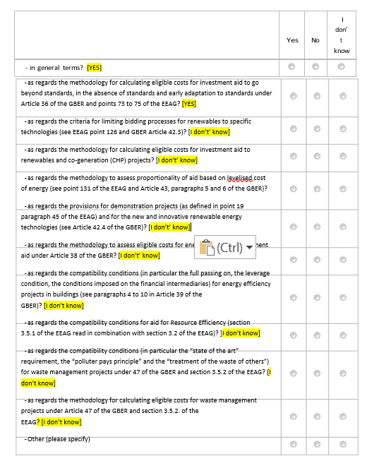
Please explain
5000 character(s) maximum

Regarding the second question the methodology on calculating eligible costs for investment aid to go beyond standards under art 36, we heard that in some countries supporting programmes going beyond standards for new buildings were cancelled as it was too difficult to prove the compliance with art 36. The Member State was asked to submit calculations of a counterfactual comparison for each individually supported project, which was seen as too much of an administrative burden. There was also a risk of a post-implementation overcompensation test which is often not feasible on a real-estate market.

In some countries art. 39 has not been used due to the hurdle of showing compliance with detailed rules for example around financial instruments. In Slovakia projects run into significant delays as occupants living in condominiums or single-family houses that also own businesses - with activities not connected to these houses (no hostels, hotels, etc.) – had to perform additional administrative work before the projects could start. It appears that art 39 is not being used in such cases due to the hurdle of showing compliance with detailed rules and instead compliance of building renovation programmes with GBER is shown by using art 38.

It would be advisable if the Commission could look into such matters to clarify or adapt state aid rules to support public authorities, building occupants and market actors to unlock the energy efficiency potential in the EU building stock.

In this section, we would like to know your opinion on the extent to which the EEAG and the related GBER provisions are coherent with other EU policies and legislations.

QUESTION 18
Based on your experience, have the EEAG and GBER adequately addressed recent market developments or technological changes such as:
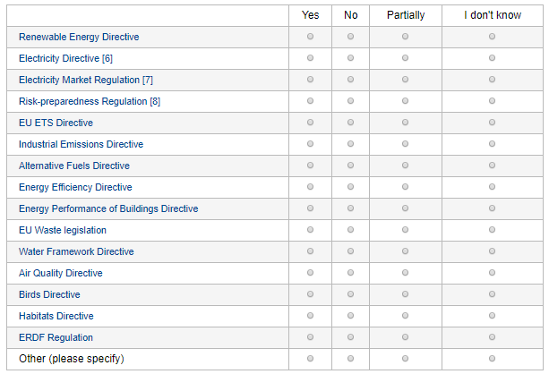
Please explain
5000 character(s) maximum

In relation with the new framework for energy efficiency measures, we support the full implementation of the “energy efficiency first” principle and its embodiment as an objective of common interest and guiding principle in the next guidelines. As recommended by recital (64) of the Governance Regulation: “Member States should use the energy efficiency first principle, which means to consider, before taking energy planning, policy and investment decisions, whether cost-efficient, technically, economically and environmentally sound alternative energy efficiency measures could replace in whole or in part the envisaged planning, policy and investment measures, whilst still achieving the objectives of the respective decisions. This includes, in particular, the treatment of energy efficiency as a crucial element and a key consideration in future investment decisions on energy infrastructure in the Union. Such cost-efficient alternatives include measures to make energy demand and energy supply more efficient, in particular by means of cost-effective end-use energy savings, demand response initiatives and more efficient conversion, transmission and distribution of energy.”
This should find a direct, effective translation in several aspects of the next guidelines that are not directly related to creating new energy efficiency measures. In particular, energy efficiency measures and demand side response initiatives should be taken into account when assessing the need for, and size of, capacity mechanisms.

END

About the European Alliance to Save Energy (EU-ASE)

EU-ASE was established in December 2010 by some of Europe’s leading multinational companies. The Alliance creates a platform from which our companies (Danfoss, Kingspan, Knauf Insulation, Saint-Gobain, Schneider Electric, Siemens, Signify, and Veolia) can join with politicians and thought leaders to ensure the voice of energy efficiency is heard from across the business and political community.

EU-ASE members have operations across the 28 Member States of the European Union, employ over 340.000 people in Europe and have an aggregated annual turnover of €115 billion.

